Tuple

Name – Archisman Roy 26/11/2020

CSE 2nd year 3rd sem

Roll – 50

1. Complete all the shell functions and programs given in the material. Write down your observations(1 line each).

Ans :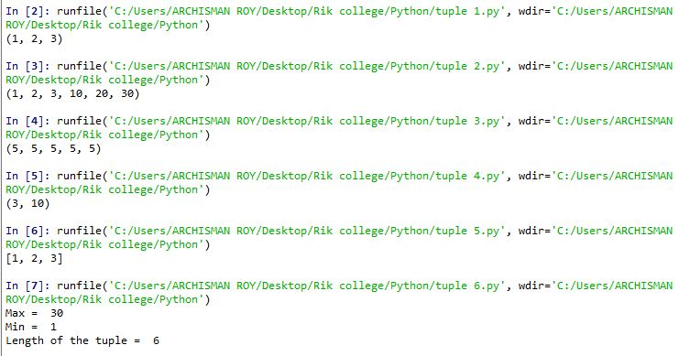

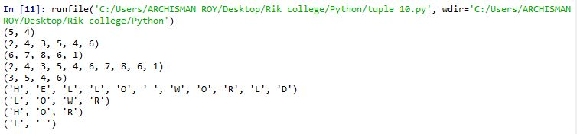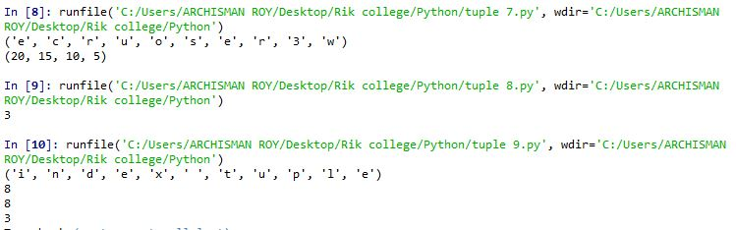

a> Like list operations tuple operations are easy to implement in Python.

b> Tuples can be concatenated easily using ‘+’ symbol, just like it’s counterparts like lists,strings.

c> Tuples can be created without using a for loop because it considers every element as a string , so the tuple can be appended to itself.

d> Like lists, tuples can also be sliced to get the desired output.

e> Lists can be converted to tuples using typecasting.

f> Certain in-built functions can be used on tuples in Python.

For Program 1:

In-built functions help us to reverse a list. So to reverse a tuple we need to first convert it into a list and then use reversed() function which itself returns a list. So we need to convert the list back into a tuple using typecasting.

For Program 2:

The isinstance() function in Python returns True if the specified object is of the same type and otherwise False. So it’s prototype looks like isinstance(object,type)

The program first checks if every element is a tuple or not. If it is, it breaks out of the loop while the ctr returns the count of elements until then.

For Program 3:

The index function is used to search for an element in a list or a tuple. It returns the index at which the search element is present. If the element is not present it returns a ValueError which can be avoided using a try & error block.

For Program 4:

Like lists, tuples can also be sliced using slicing method in Python.

1. Write a program in Python to do searching either linear or binary. The choice will be provided by the user.

Ans :

